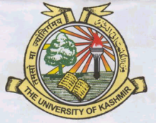Institute of Home Science

**THE UNIVERSITY OF KASHMIR**

### No: F(Date-Sheet- 3rd Sem)H.Sc/KU/18

Dated:-06-09-2018

**DATESHEET**

**Datesheet of M.Sc Home Science 3rd Semester (Backlog)**

Time: 11: 00a.m (Friday 10:30a.m)

**3rd Semester (Backlog)**

|  |  |  |
| --- | --- | --- |
| **Date & Day** | **Title of the course** | **Course No.** |
| 10-09-2018  (Monday) | Women, Nutrition & Health | HSC14311EA |
| 12-09-2018  (Wednesday) | Community Nutrition | HSC14310EA |

**Sd/-**

**Prof. Naheed Vaida**

**Director**